Accessibility in Reading for Blind and Low Vision Adults

UX Research Report

Cartoon avatar of Cassandra, a female with light skin, a blonde pixie cut, and wayfarer glasses who smiles broadly

Prepared by: **Cassandra F Mendez**Project Stakeholder: **Felesia McDonald**

UXD 60113: Researching the User Experience II  
Kent State University  
11 December 2022

**Table of Contents**

1. Introduction

2. Executive Summary

3. Methods and Participants

4. Domain Terminology

5. Synthesis

Finding and Accessing Books

Barriers in Book Access

When and How Readers Read

Difficulties in Reading

Physical Books

6. Personas

Blind Persona: Maria

Low Vision Persona: Eva

7. Persona Journey

8. Recommendations

9. Appendix

Interview Guide

Text Alternatives

Blind Persona Alt Text: Maria, 27

Low VIsion Persona Alt Text: Eva, 24

Persona Journey Map Alt Text

# 

# 1. Introduction

This project seeks to understand how blind and low vision (visually impaired or VI) readers access and read books for a variety of needs, including school, professional enrichment and leisure reading. To do this, Cassandra has needed to discover readers’ habits, preferences, and potential pain points by investigating the following high-level research themes:

* How do blind and low vision readers find and access books they want to read?
* What barriers do readers encounter when looking for books?
* When and how do blind and low vision readers read?
* What makes reading difficult?

# 2. Executive Summary

The Synthesis section goes into detail on each of the above research themes, but below are the most prominent discoveries.

1. **Accessing Books****: Well-maintained library services for the blind and visually impaired are important for all readers.**7 of 9 participants regularly made use of library services for the blind and said they’ve improved over time by expanding their databases.
2. **Barriers in Access****: Readers often have to individually search platforms to find a book.**

Instead of searching once to learn where books are hosted, readers frequently perform redundant searches. See Persona Journey for an example.

1. **How Readers Read****: Customizability is key.**  
   All readers enjoyed the option of adjusting audio speeds, sleep timers, or changing font size and contrast.
2. **Difficulties in Reading****: Not all readings are suited for audio.**  
   Some genres, as well as proofreading, technical reading, and poor audio quality can make audio impractical.
3. **Difficulties in Reading****: PDFs are challenging to read.**

PDFs aren’t customizable by nature, and low vision readers must employ unique, but imperfect, problem-solving skills to read.

1. **Physical books** **have important emotional significance.**  
   All readers mentioned missing the feel of turning pages and that the romanticism of reading is lost when reading via audio or digital.

# 3. Participants & Interview Process

Cassandra recruited and interviewed nine readers, four blind and five low vision corresponding to both target reader types.

A group of five avatars: P1, P3, P6, P7, and P8A group of four avatars: P2, P4, P5, and P9

She developed an interview guide to uncover readers’ current setup and their jobs-to-be-done with reading.

All interviews were conducted individually and remotely over Zoom. Sessions were recorded with participants’ consent, and recordings are available at the links in the table below.

Cartoon avatar of P1, a female with light skin and short, blonde hair who closes her eyes and smiles with her teethCartoon avatar of P2, a bald male with medium skin who smiles and closes his eyesCartoon avatar of P3, a male with light skin and dark, cropped hair who smiles and raises an eyebrow

| **P1** 29, F, Low Vision Program Support Specialist & Aspiring Transcriber (Braille certification in progress) Memphis, TN | **P2** 37, M, Blind Digital Accessibility Specialist California | **P3** 26, M, Low VIsion Student (MS in Conflict Management) Cumming, GA |
| --- | --- | --- |

Cartoon avatar of P4, a female with light skin and long, tousled brown hair who winks and sticks out her tongueCartoon avatar of P5, a female with medium skin and long dark hair who grins and looks relaxed with closed eyesCartoon avatar of P6, a female with very fair skin and long white hair who winks with rosy cheeks and pursed mouth

| **P4** 25, F, Blind Communications Associate & Student Student (MFA in Writing Popular Fiction) Louisville, KY | **P5** 25, F, Blind Software Engineer New Jersey | **P6** 21, F, Low Vision Student (BS in Astrophysics) Philadelphia, PA |
| --- | --- | --- |

Cartoon avatar of P7, a female with very fair skin, long light blonde hair and sunglasses who smiles broadlyCartoon avatar of P8, a female with very fair skin, long white hair and round glasses who smiles pleasantlyCartoon avatar of P9, a female with fair skin and short blonde hair who grins with eyes closed

| **P7** 20, F, Low Vision Student (BS in Education & BA in History) Illinois | **P8** 23, F, Low Vision Paralegal San Francisco,v CA | **P9** 25, F, Blind Social Worker Ohio |
| --- | --- | --- |

# 4. Domain Terminology

Since this domain is a smaller niche, not everyone will understand the technologies and nonprofit library sources readers use. The below glossary provides definitions for frequently used tools referenced in the rest of this report.

1. [**NLS BARD**](https://www.loc.gov/nls/braille-audio-reading-materials/bard-access/): A government program through the Library of Congress, NLS (the National Library Service for the Blind and Print Disabled) is an accessible library program for the “print disabled,” which includes visually impaired, learning disabled, and physically disabled (where it would be difficult to hold a book) readers. Qualifying readers can then access BARD (Braille and Audio Reading Download) and listen to audiobooks or read on a **Braille display** using an app like **BARD Mobile**. Blind readers can also request a physical, Braille manuscript which will be mailed to them. NLS & BARD are free to all qualifying readers.
2. **BARD Mobile**: A mobile app that pairs with **NLS BARD** where users can access the Library of Congress’ vast collection of audio and Braille books on their mobile devices. Users can change audio speed and set sleep timers on the app.
3. [**Bookshare**](https://www.bookshare.org/cms/): A nonprofit dedicated to improving book access for the print disabled. Members can read from Bookshare’s library digitally using a computer, tablet, or phone with an appropriate reading application such as **Voice Dream**; audibly using a **speech synthesizer** built in to their chosen reading application; or tactilely using a **Braille display**. Bookshare membership is free for students and at cost for non-students.
4. **Braille display**: A physical device that contains a row of holes with plastic pins that can emerge and retract to create Braille letters and symbols. Users can connect this device to a computer, phone, or tablet via Bluetooth and read output from a **screen reader**, or connect a memory card and read specially formatted books. Once a user reads a line with their finger, they push the Refresh button to read the next line, and so on.
5. **CCTV**: A Closed-Circuit Television used for the purpose of magnification. Users can place what they want to read under the camera and read the output on the screen while zooming in and changing color contrast options to suit their needs.
6. [**Learning Ally**](https://learningally.org/): A nonprofit dedicated to improving literacy in children and students. Qualifying print disabled students can access Learning Ally’s library of digital and human-read books and textbooks. Membership is provided to qualifying students through their institution or at cost to non-students.
7. **OCR**: Optical Character Recognition is a form of electronically converting images of text to their ASCII electronic encoded characters. This allows readers to search through scanned documents using Find functionality and read images of text (like PDFs) using a screen reader.
8. **Screen magnification**: Accessibility software, often built into a computer or mobile device’s operating system, that allows users to enlarge their entire screen. Users can zoom in on parts of the screen at a time, panning with their mouse pointer or fingers to move the view to other parts of the screen. It’s similar to using a magnifying glass to read print.
9. **Screen reader**: Accessibility software, often built into a computer or mobile device’s operating system, that reads information on the screen. Users can move from element to element, generally from top to bottom and left to right, and hear the output.
10. **(Speech) Synthesizer**: Software that reads out loud to the user. Synthesizers are built in reading applications and read the contents of the book or document, as opposed to the entire screen like a **screen reader**.
11. [**Voice Dream Reader**](https://www.voicedream.com/reader/): A mobile app that pairs with **Bookshare** allowing users to read from Bookshare’s library digitally or using a synthesizer. Users can customize font size, foreground and background colors, and font family to their preference.

# 5. Synthesis

Regardless of the reader type they were, most readers (6/9) read daily and the other three read several times weekly. Nearly all read for leisure with the exception of P3. For non-leisure reading, 8 of 9 read for another purpose: half (P3, P4, P6, and P7) were traditional students enrolled in a Bachelors or Masters program, P1 pursued a certification, P2 and P9 read for professional enrichment, and P8 read for work.

Additionally, nearly all readers used audiobooks, with the exception of P6 and P9 who read using a screen reader with digital books. Most (3 of 4) blind readers also read using a Braille display regularly, and all five low vision readers read visually in some way either digitally or using a CCTV.

## Finding and Accessing Books

“I’m grateful for all the access that has been given to us with books and all the [technological] improvements… and improved quality of it.” P4, on accessing books

When it came to finding books to read, readers often had a variety of tools they used in conjunction with one another. For leisure reading, 3 of 4 blind readers used BARD Mobile and Audible as the dominant sources for audiobooks and Bookshare or BARD for use with their Braille displays, while P9 used a screen reader. Low vision readers had diverse approaches. For audio, P1 used Libby, P7 used Learning Ally, P3 had audio files created for him by a private reader contracted by his state’s services for the blind, P8 used BARD Mobile, and P6 didn’t read with audio. When visually reading, 4 of 5 used Bookshare, 2 naming it as their first choice and the other 2 as a backup option.

Those who read for non-leisure activities including school, professional enrichment, and certification work, all got materials in unique ways. P6 and P3 read academic journals and got PDFs from their journals’ websites or a library archive. P1 got her certification materials directly from the National Federation of the Blind’s Library of Congress Braille transcription course. P8 accessed law books from a digital library archive. P6 got any textbook PDFs from Office of Disability Services or from friends while P3 got textbooks from the university online library services. P7 used Learning Ally for most of her textbooks. P2 used O’Reilly’s publishing library app to read professional enrichment books on software engineering, a subscription provided by his employer. P9 purchased most of her professional books from iBooks or rented them on Kindle.

Finally, for reference books like cookbooks and religious texts, most used online resources although results were also scattered. 5 of 9 accessed the Bible for personal or academic use, three of which were low vision and used a physical printed Bible with magnification or large print. P6 got a Bible on Bookshare, and P4 uses the Bible Gateway mobile app with her Braille display. For cooking, three low vision readers also had physical cookbooks they read with the naked eye or using a phone camera to freeze and zoom in to read, and two blind readers mentioned asking assistants like Alexa to read them recipes.

## Barriers in Book Access

"I feel like now there’s often options [when you can’t find a book], not necessarily in the most preferred format.” P8, on searching for books

All nine said in different ways that accessing books is easier now than it's ever been. Most added that they remembered times where audiobooks weren’t as popular and were happy that sighted people embraced them as well so the supply of quality audiobooks is wider.

All readers had a personalized “decision tree” of their preferences and would check their “first choice” preferred reading source, then move along various nodes depending where they could find the book they wanted in the form they wanted it in (audio, Braille, digital). For most (7 of 9), their preferred source was free, using services like Libby, BARD, Bookshare/Learning Ally (for students), or their university library. Most would then settle for buying a book if their preferred didn’t have it or they needed it immediately, using Kindle, iBooks, or even Amazon for a physical copy.

Although rare, readers approached difficulty finding a book in a variety of ways. If for leisure, most readers would just find a different book. If required for a course, 3 of 9 mentioned working with their professors or their school’s disability services to find an accommodation, either as a PDF version or alternative book. P6 would reach out directly to Bookshare to add the book to their library, and P3 used the university library from a previous enrollment (transferred out of law school) when his university’s library didn’t have what he wanted; P6 requested Bookshare to add it to their library which would take about a week.

## When and How Readers Read

"When you have a disability, you become smart with what you need to do.” P7, on reading workarounds

Every participant described reading as a ritual, meaning that they would get most pleasure from reading in their homes in silence or with some music. Some lit up as they described their perfect environment: low or no lighting, a comfy chair, couch, or bed, and nothing to do but get lost in their story (P4 added the sound of rain and P8 mentioned enjoying a puzzle in their descriptions). Additionally, all mentioned sometimes listening to audiobooks while commuting or multitasking in addition to reading as a ritual.

To customize their reading experience, most audiobook readers adjusted the speed somehow; 5/8 increased the speed while P5, P3, and P7 left it as normal. This could vary for all: sped up if they needed to finish reading quickly, slowed down to improve comprehension or to enjoy the story at its regular pace without any audio clipping.

For low vision visual reading, 4 of 5 readers read digitally, three on a phone or tablet and P1 using a Kindle, whereas P3 used a CCTV with physical books.. For customizing, all four digital readers increased the font size considerably and three inverted the contrast to minimize eye strain. Reading endurance hovered around an hour, although it varied.

All blind readers but P9 regularly read in Braille. P5 and P2 described Braille as more of a conscious choice to keep up their literacy skills since they needed to rely on it later in life as teens. P4 prefers Braille since she relied on it sooner, but admits it takes longer than audio. All three mentioned using Braille to improve comprehension since it was less passive than listening to an audiobook and demanded more mental energy. Reading endurance was also about an hour for P2 and P5 though P4 could read longer. Separately, P9 chose not to read in Braille, describing her Braille display as cumbersome and enjoying the modern approach of simply using a screen reader to read a book.

Readers employed a fascinating degree of ingenuity when it came to non-leisure reading workarounds. 3 of 4 blind readers would use screen readers with reading apps that didn’t have an audio component. All five low vision readers accessed PDFs for non-leisure reading and read them by utilizing applications not intended for reading. P1 and P7 read using screen magnification on their computers. P3 would sometimes copy & paste PDF contents into MS Word and select the “Read Aloud” functionality. P6 imported academic journal PDFs into the Notability note-taking app on iPad and would magnify and pan back and forth to read. P8 made use of her firm’s Adobe Premium access which would OCR PDFs so she could use a screen reader to listen to its contents. Finally, some readers created their own solutions: P3 had a hired reader for his school materials and uploaded files on a shared drive, and P7 would sometimes create her own PDFs by using her phone’s Notes app to scan pages and upload them on Google Drive.

## Difficulties in Reading

“I’m very interested in making those [PDFs] more accessible… There’s no reason screen readers shouldn’t be able to read equations.” P6, on PDF accessibility and audio limitations

Time spent reading varied greatly regardless of reading method (Braille vs. digital) and depended more on readers’ endurance, the subject matter (technical or leisure), and mental and emotional state (desire, deadline pressure, mental exhaustion). Additionally, low vision readers mentioned not being able to visually read outdoors because of harsh lighting causing eye strain.

Some readers mentioned limitations of audio as a medium. P4 reads many fiction novels across genres for her MFA program and remarked that some things aren’t well suited for audio,, depending on writing style (like Choose Your Own Adventure novels) and the audiobook narrator themselves (heavy accents or mumbling). Proofreading is also difficult using a screen reader, which often doesn’t capture missing punctuation or spelling errors. Furthermore, technical reading is difficult using a speech synthesizer on something like Bookshare with complex formulas, images, charts, tables, and figures that require more audio description best done by a human. Most technical readers had heard of or tried a service like Learning Ally, but some were disappointed and tried other workarounds like volunteer or hired readers.

Finally, low vision readers struggle with PDF reading. Since PDFs are not editable, readers can’t increase font size or contrast. All low vision readers used workarounds to read, none of which were ideal. Thus, low vision readers weren’t able to read PDFs for as long as they could read leisure materials before feeling strained.

## Physical Books

"If I didn’t have a disability, I’d still definitely want to read physical books.” P1, on physical books

One final, fascinating discovery emerged beyond the research topics on feelings surrounding physical books, despite most readers being unable to use them. Every reader mentioned missing the feel of reading physical books, either print or Braille. Most blind readers had some vision earlier in their lives and low vision readers often forced themselves to read smaller print since e-books weren’t as prevalent in their youth. Readers were almost embarrassed about this since they couldn’t read them anymore, but this shows that books are much more than simply printed words.

Blind readers all mentioned the special feel of turning the pages, and most mentioned occasionally requesting a Braille manuscript from NLS BARD if the mood felt right. They all laughed at the impracticality while explaining that some books they ordered came in several boxes of bulky volumes, but they got to read a physical book. Low vision readers wished they had the option to read comfortably, with P1 saying, “If I weren’t disabled, I would never use an e-reader,” but was grateful to have the option.

For some, they were collectors’ items, like beautiful boxed sets or signed copies. For P3, they were trophies of accomplishment, and P6 would put them next to her as good luck charms. P4 and P7 loved the distinct “book smell.” P6 would also have physical copies to loan to friends, creating a social connection despite not reading those copies herself.

# 6. Personas

Although blind and low vision readers shared many traits, Cassandra created separate personas to accurately capture their divergences, namely Braille versus enlarged print and screen reader versus magnified PDF reading. These personas were created after the first six interviews, using participant responses to capture each type of reader more completely and used as a basis for recruiting the final three. Text versions for screen reader users are written in the Appendix.

## Blind Persona: Maria

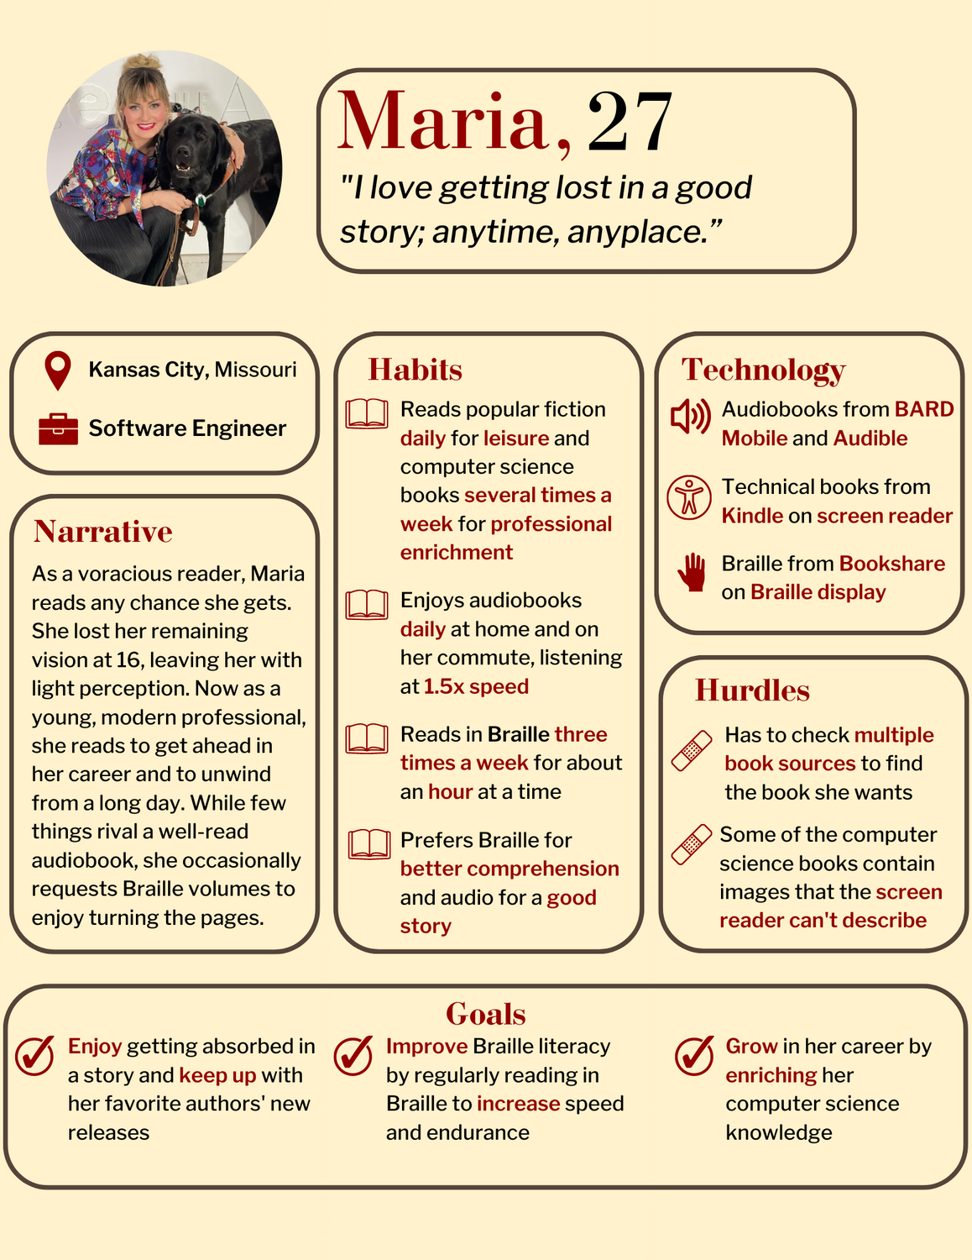

## Low Vision Persona: Eva

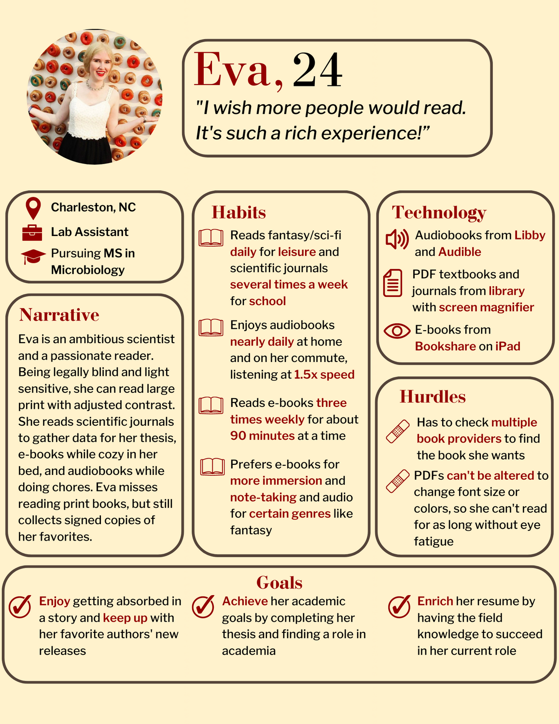

# 7. Persona JourneyMaria persona journey

# 8. Recommendations

Given most readers enjoy the flexibility in use of their current solutions, these recommendations are not intended to replace any one tool, but rather make reading more efficient for blind and low vision readers..

1. **Leverage nonprofits to ensure all blind and low vision readers know about the services available to them.**

In casual conversation after interviews, the only two participants who didn’t use services specific to the blind like BARD were unaware of them or had learned about them years ago but never adopted. This gap in knowledge could have easily been prevented by nonprofits they were involved with promoting these services.

1. **Allow readers to perform one search for a book by leveraging a service they already use.**

As mentioned in the journey map above, readers could use something like Google, Goodreads, or an accessible reading equivalent like the National Library Services for the Blind to know where books are available across platforms. More research would need to be done to determine where it would best benefit readers.

1. **Ensure reading platforms have granular levels of customization.**  
   Many readers mentioned choosing one platform over another because they liked the customization options. Companies wishing to make their platforms competitive should allow deeper customization to attract more readers (e.g. RGB-level color tweaking as opposed to color presets, increasing speed by 0.1x rather than 0.25x).
2. **Prioritize audio quality improvement on older recordings.**  
   While this won’t solve all audio limitations, it will benefit users who primarily rely on audio as a medium.
3. **Work with a company like Adobe to allow access to open-source or free to print disabled PDF resources to improve accessibility.**

Ultimately, PDFs will always be imperfect, but they are here to stay. Putting accessibility behind a paywall is in itself inaccessible. Low vision and blind readers should have PDF customization options in addition to library services since nearly all readers interviewed dealt with them.

1. **Offer more large print and Braille books in mainstream stores and libraries.**

It doesn’t have to be a large section, but carrying books in a format that blind and low vision readers can use sends a powerful message that they belong.

# 9. Appendix

## Interview Guide

Below is the interview guide used when interviewing all nine participants.

Key:

**Moderator prompt**

*Optional question*

| **Section & Timing** | **Total Timing: 45 minutes** |
| --- | --- |
| **Intro**  **5 minutes** | Thanks for participating in my research! I really appreciate your time.    My name is Cassandra and I’m a Masters student at Kent State University studying User Experience Design, and I have low vision. I’m conducting research to learn how blind and low vision people access and read books, and what challenges or barriers readers encounter.    This is investigative research, so you’re teaching me about your experience. There are no wrong answers! Also, let me know if you’d like to stop at any time or no longer want to participate and we’ll end the session.  I have a few questions I’d like to ask to start. After that we’ll move on with the interview. The process should take around 45 minutes.  We’d like to record this session,, so I wanted to make sure you were aware of that before we started. I can assure you that the video we take will only be for our internal use; it will not make its way onto the Internet.  I’m going to read you this informed consent document. If you’re OK with this, please verbally indicate this by saying “I consent”  ***- - PROVIDE (OR READ TO THEM) INFORMED CONSENT FORM - -***    Do you have any questions before we start? |
| **Warm up**  **5 minutes** | Let’s get started with some general questions.  Tell me a bit about your vision (“what CAN you see?”)  When do you read a book? (this can be leisure, school, professional enrichment, etc., aka ***jobs to be done***)  How often do you read for ***JTBD***? |
| **Theme 1: Accessing Books**  **15 minutes** | How do you access or find books for ***JTBD***?  What do you like about the way(s) you currently access books?  Have you used different ways to access books for the same need? When would you pick one over the other?  When have you had a difficult time finding a book through your chosen method? What did you do?  When was the last time you used a physical book as opposed to digital?  *How do you feel about reading physical/analog books? Why?*  Do you access reference books like cookbooks or handbooks? How?  Scenario: you’re told to read a specific book for school/work/book club. What steps would you take? |
| **Theme 2: Reading**  **15 minutes** | Describe your most common reading environments (time/place/situation)  What is your ideal reading environment?  What factors contribute to choosing one method of reading over another? (ex. Kindle vs. audio)  How do you customize your reading method (e-reader font, audiobook speed)? *Can you show me?*  When and where is reading most enjoyable?  When is reading difficult?  When do you get physically tired of reading?  Do you ever switch reading methods partway through reading a book? When?  Scenario: someone gives you a book as a gift. How do you feel? How would you go about reading it? |
| **Wrap-up**  **3-5 minutes** | Thanks for your time, that was extremely helpful.  Any final thoughts about books or reading?  Do you have any questions for me?  If we have any follow-up questions, may I contact you directly? It could be a few short questions via phone.  [If yes; confirm contact info] |

## Text Alternatives

Below are the text versions of complex images used in this report.

### Blind Persona Alt Text: Maria, 27

**Quote**: "I love getting lost in a good story; anytime, anyplace.”

**Location**: Kansas City, MO

**Occupation**: Software Engineer

**Narrative**: As a voracious reader, Maria reads any chance she gets. She lost her remaining vision at 16, leaving her with light perception. Now as a young, modern professional, she reads to get ahead in her career and to unwind from a long day. While few things rival a well-read audiobook, she occasionally requests Braille volumes to enjoy turning the pages.

**Technology**:

* Audiobooks from BARD Mobile and Audible
* Technical books from Kindle on screen reader
* Braille from Bookshare on Braille display

**Habits**:

* Reads popular fiction daily for leisure and computer science books several times a week for professional enrichment
* Enjoys audiobooks daily at home and on her commute, listening at 1.5x speed
* Reads in Braille three times a week for about an hour at a time
* Prefers Braille for better comprehension and audio for a good story

**Goals**:

* Enjoy getting absorbed in a story and keep up with her favorite authors' new releases
* Improve Braille literacy by regularly reading in Braille to increase speed and endurance
* Grow in her career by enriching her computer science knowledge

**Hurdles**:

* Has to check multiple book sources to find the book she wants
* Some of the computer science books contain images that the screen reader can't describe

### Low VIsion Persona Alt Text: Eva, 24

**Quote**: "I wish more people would read. It's such a rich experience!”

**Location**: Charleston, NC

**Occupation**: Lab Assistant

**Student Status**: Pursuing MS in Microbiology

**Narrative**: Eva is an ambitious scientist and a passionate reader. Being legally blind and light sensitive, she can read large print with adjusted contrast. She reads scientific journals to gather data for her thesis, e-books while cozy in her bed, and audiobooks while doing chores. Eva misses reading print books, but still collects signed copies of her favorites.

**Technology**:

* Audiobooks from Libby and Audible
* PDF textbooks and journals from library with screen magnifier
* E-books from Bookshare on iPad

**Habits**:

* Reads fantasy/sci-fi daily for leisure and scientific journals several times a week for school
* Enjoys audiobooks nearly daily at home and on her commute, listening at 1.5x speed
* Reads e-books three times weekly for about 90 minutes at a time
* Prefers e-books for more immersion and note-taking and audio for certain genres like fantasy

**Goals**:

* Enjoy getting absorbed in a story and keep up with her favorite authors' new releases
* Achieve her academic goals by completing her thesis and finding a role in academia
* Enrich her resume by having the field knowledge to succeed in her current role

**Hurdles**:

* Has to check multiple book providers to find the book she wants
* PDFs can't be altered to change font size or colors, so she can't read for as long without eye fatigue

### Persona Journey Map Alt Text

Persona: Maria

Scenario: **Find and read “Where the Crawdads Sing” that her friend Kat recommended to talk about it**

**Expectations: Quickly read a synopsis and download it on her favorite audiobook source with her customizations**

**Phase 1: Investigate**

1. Search Google for the title
   1. Thinking: “I’ve heard of this book before, but I’m not sure what it’s about…”
2. Scroll to find the Goodreads result
3. Read the synopsis and reviews
   1. Thinking: “Oh neat, a murder mystery, sounds exciting! I think I’d like to listen to this one.”

**Phase 2: Search**

1. Open BARD Mobile
2. Search the title
3. Listen to an excerpt
   1. Thinking: “Great, this reader is good. I wonder what the Audible version is like.”
4. Open Audible
5. Search the title
   1. Thinking: “Ugh, again?? Maybe I should’ve copied and pasted this title…”
6. Listen to an excerpt
   1. Thinking: “Hmm, it’s good, but not worth buying another-token good. I’ll get it on BARD for free.”
7. Download the book on BARD

**Phase 3: Read**

1. Press play
   1. Thinking: “Nice, I like this reader’s voice so far, but 1.5x feels a little fast for a more suspenseful book.”
2. Increase the speed to 1.25x
   1. Thinking: “There, that’s better. Not too fast or too slow.”
3. Listen while doing chores
4. Set a sleep timer before bed
5. Listen in the morning
6. Finish the next evening

**Phase 4: Discuss**

1. Meet Kat for coffee
   1. Thinking: “I’m so glad Kat recommended this to me! Right up my alley. Any other suggestions?
2. Talk about the book

**Insights**: Readers should be able to know where a book they want to read will be available before searching directly on their platform of choice or comparing multiple options redundantly. Maria wanted to learn and compare, and instead had to type the title three times.

**Opportunities**: A site like Google or Goodreads could have a list letting readers know where books are available, including options for the print disabled. This would be similar to searching for a movie and finding which streaming service it’s on.