Worthington Libraries Information Architecture: Analysis & Recommendations
Cassandra Mendez
UXD 60111 Information Architecture II
10 December 2023
1. Overview
Project Activities
2. Users & Context
User Goals
3. Personas & Tasks
Primary: Priscila the Patron
Secondary: Malika the Mom
Secondary: Ignacio the Immigrant
User Tasks
4. Proposed Navigation Structure
Repurposing Existing Content
Reworking Content
Adding New Content
Appendix
Sitemap
Wireframes

1. Overview
The Worthington Libraries are centrally important to their community, and organization is a paramount priority.
The library director has the following goals for the website:
- Navigating: patrons can find the information they need, whether it’s the online catalog, event information, or additional library services.
- Organizing: content on the site is organized logically for the context of use. For example, choosing between alphabetical and priority-driven organization depending on the patrons’ expectations.
Since the Worthington Library is a small town with minimal funding, they’ve sought out external consultants to provide guidance and recommendations to modernize and improve their existing site.

Project Activities
To get a holistic view of the site and areas for improvement, the following project activities and deliverables were completed:
- Create a project proposal, giving an overview of the goals, current gaps, and the project plan.
- Phase 1: Understand the site’s users and their goals by conducting interviews with librarians, performing a literature review, and preparing a report with library site user personas and their primary tasks
- Phase 2: Analyze content by performing a content analysis, choosing a classification scheme and drafting a sitemap, then testing the proposed taxonomy using Treejack
- Phase 3: Draft wireframes by incorporating results from the Treejack study and refine by performing first-click testing using Chalkmark
- Create final report deliverable: combining all previous materials for a final recommendation

2. Users & Context
To better understand the library site’s users, three librarians from Worthington Libraries were interviewed in person: two from the Worthington Park branch and one from the Old Worthington branch.
Many patrons are first directed to the site when visiting in person and guided by a librarian or library staff. All three librarians mentioned providing a significant amount of technology assistance as part of their roles, including help on navigating the online catalog and learning how to look up information on library services, since many patrons have limited technology and/or English literacy.

User Goals
Worthington Libraries’ patrons have several overarching goals when using the site.

Plan a visit
This includes physical branch addresses and hours of operation.

Ask a question
Many patrons seem to approach the library site in a similar fashion to visiting a physical branch: instead of searching for information themselves, they frequently reach out to ask questions by phone, online chat, or by submitting a question via the online help desk. These requests vary greatly in nature and can include recommendation requests, research topics, making a reservation on their behalf, reviewing a resume, or inquiring about a specific service.

Learn about free services
Public libraries remain highly relevant in a digital age by providing free services to the community, including reliable computer and internet access. All three librarians regularly coach patrons how to find information on the website for popular services, including:
- Study and meeting room reservations
- Printing, faxing, and scanning
- COVID-19 test kits
- Notary services
- English speakers of other languages (ESOL) classes
- Access to digital databases, like OverDrive (Libby)
- Voter registration information

Browse the catalog & reserve items
One of the library’s essential functions, patrons still make frequent use of the online catalog for materials in a variety of formats, including physical books, audio/e-books, and physical media (CDs/DVDs).

3. Personas & Tasks
Most adults visiting Worthington Libraries have similar needs and can be broadly summarized in one primary persona, Priscila the Patron. Priscila’s goals are not mutually exclusive, and can apply to either secondary persona, Malika the Mom or Ignacio the Immigrant.


Primary: Priscila the Patron
photo generated using AI
Name: Priscila Roman
Age: 31
Occupation: Home health aide and nursing student
Narrative: Priscila is a regular at the Worthington Park branch close to her apartment, but especially this past year as she’s gone back to school part time to get her nursing license. She often goes to the library for a quiet place to study and get online since her connection is spotty at best at home. Sometimes, she invites her study group to the library so they can get work done together and trade notes. When she’s not busy with work and school, she loves reading mystery audiobooks from her phone, getting engrossed in the story.
Goals:
- Reserve study rooms for her to spread out her materials or work aloud with a group
- Find and use textbooks for her classes to avoid the expense of buying them
- Scan textbook pages to read the next chapter at home
- Print her papers and reports to turn in
- Check COVID-19 test kit availability to make sure she doesn’t spread infection to her elderly patients at work
- Ask a librarian for resume review as she applies for new jobs in nursing
- Access digital databases to listen to audiobooks
- Ask a librarian for book recommendations to find her next mysterious read
- Check her voter registration to stay civically involved

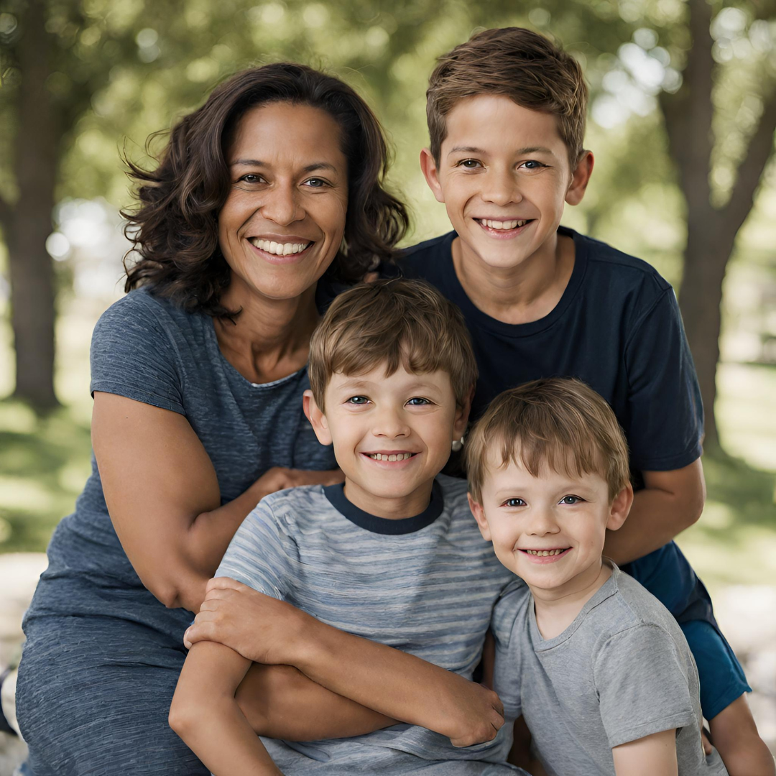
Secondary: Malika the Mom
photo generated using AI
Name: Malika Campbell
Age: 44
Occupation: Stay-at-home mom
Narrative: Malika would move mountains for her three boys, Peter (13), Adrian (7), and Jordan (14 months). Juggling three very different schedules and needs, it can be challenging to provide them what they need. Malika is on the PTA and also leads a book club for her friends. Fortunately, she can get a lot done for all four of them while at the library!

Goals:
- Social events and hangout time for Peter so he can meet other teens and have time of his own with them
- Homework help and tutoring for both Peter and Adrian to understand tricky math concepts for their grade level
- Age-appropriate reading materials for Adrian, an advanced reader who loves a challenge
- Storytimes and mom activities for Malika and Jordan
- Print materials for the PTA meeting surveys
- Find a new book for Malika’s book club

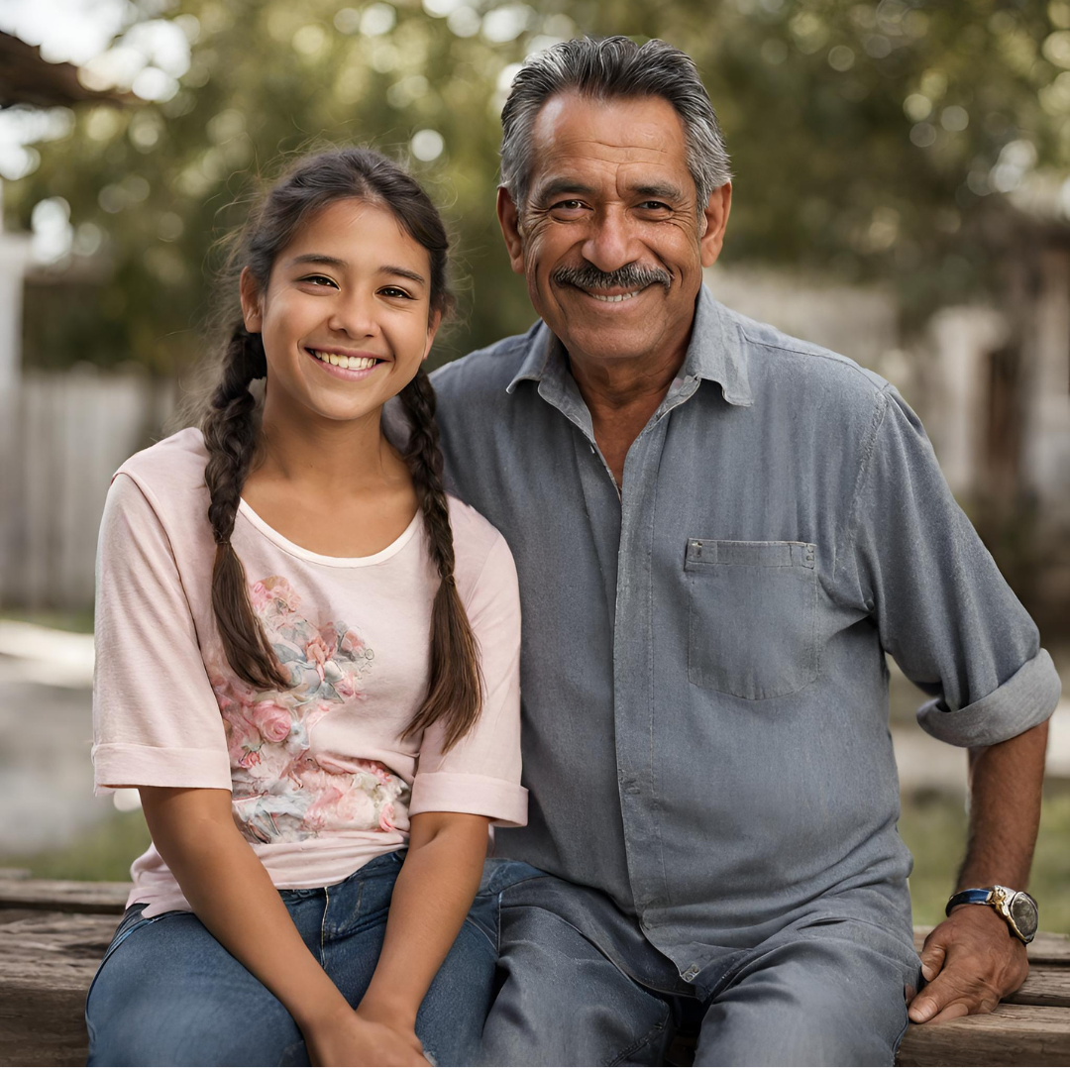
Secondary: Ignacio the Immigrant
photo generated using AI
Name: Ignacio Robles Perez
Age: 50
Occupation: Site reliability engineer
Narrative: Ignacio was recently transferred from his firm’s office in Mexico City to their headquarters in the Columbus area. Renting a place in Worthington so his teen girl can finish high school in a competitive school district, his family is navigating the change in status. While his wife and daughter know English well, Ignacio is trying to learn and wants a safe environment to do so while he continues his work.
Goals:
- Access to a notary to continue the immigration process
- ESOL classes to practice and learn English
- Programs for his teen daughter to make connections after the move
- Homework help for his daughter on their literature assignments for school
- Books in Spanish to continue his leisure reading in his favorite genre: fantasy

User Tasks
With the above personas in mind, the Worthington Libraries site must support the following tasks:
Task | Priscila the Patron | Malika the Mom | Ignacio the Immigrant
High Priority Tasks
Find and reserve books | X | X | X
Reserve services (study rooms, notary services) | X | X | X
Access services (print, fax, scan, get free COVID-19 test kits) | X | X | X
Get book recommendations | X | X | X
Medium Priority Tasks
Find and register for events (age-appropriate programming, ESOL classes) |  | X | X
Get to online databases | X
Find tutoring and homework help |  | X | X

4. Proposed Navigation Structure
To accommodate the personas and their goals, a content inventory was conducted to track the site’s hierarchical structure, page titles, and navigational link labels. Additionally, it assessed which content needed to be repurposed, reworked, or added. Based on this, an organization scheme was selected, mapped in a sitemap, and tested using Treejack. Then, a wireframe for the homepage was drafted and tested using Chalkmark

Repurposing Existing Content
Though the current site is up-to-date and well maintained, there are several places where content could easily be consolidated to keep navigation predictable and simple, especially for patrons that may lack computer literacy.
- Combining the “Download” (digital databases organized by format) and “Explore” (digital databases organized by topic) from the primary navigation into one entity that houses all digital databases.
- Putting “Staff Picks,” “Picks of the Year,” and “Title Lists” (groups of related titles for a specific purpose like preparing early readers) under one “Recommendations” page that describes each.
- Uniting “Schoolwork Guides” (resources for students on a topic) and “Subject Guides” (resources for adults on a specific topic) into one “Research Guides" page with the ability to filter by audience.
- Consolidating individual pages on ways to contact the library (like text, call, chat, and online form) listed under “Services” into one “Ask a Librarian” page
  - Updated from Treejack study: originally planned to move consolidated contact pages under “Help,” but all four users anticipated librarian contact information under “Services”

Reworking Content
Since the Worthington Libraries site has existed for some time, existing content can naturally lose its relevance and create additional “noise” for a user.
- Listing services that are implied as a separate page within the “Services” page, including entries for Bathrooms, Drinking Fountains, Vending Machines, and Outdoor Seating
- Separate page for “Locations” when they’re listed on the “Visit” landing page alongside the library hours
- Rework footer links to more closely mimic the primary navigation, providing exposed, redundant points-of-entry
  - Updated in Chalkmark study: though not reflected in the sitemap, the links represented in the homepage wireframe footer performed well with test participants, as they naturally gravitated towards the exposed child pages

Adding New Content
While most of the content could be repurposed and consolidated or pruned and reworked, additions came in the form of categories and chunks of content.
- Adding a new primary navigation element to highlight library services, since patrons consistently struggle to find it in its current place under “Visit.” This simple but significant change will allow for greater visibility and empower patrons to find their answers independently.
- Enhancing primary navigation landing pages by adding content that points to each child page in its hierarchy. For example, creating a landing page for the new, consolidated “Databases" that highlights different formats and topics, as well as the consolidated “Research Guides.”
- Changing the “Calendar” subcategories from topical event types like “DIY and Crafts,” or “Games” to audience-based categories including “Storytimes,” “Kids,” “Teens,” and “Adults”
  - Updated from Treejack study: originally planned on eliminating the subcategories and allowing users to filter from the primary “Calendar” page, but users had a difficult time finding where event information for kids was
Keeping the site top-down and focusing on its hierarchy, the main point of focus is the primary navigation. Instead of the current hybrid scheme of task-based browsing using verbs like “Visit,” “Browse,” “Explore,” along with topical nouns like, “Calendar,” and “Help,” it’s recommended to use an ambiguous, topical scheme that uses simple vocabulary as compared below:
Old primary navigation
- Visit
- Borrow
- Download
- Explore
- Calendar
- About
- Help

Proposed primary navigation
- Hours & Locations
- Books, Media & e-Library
  - (updated from Chalkmark study: users struggled to find audiobooks to check out)
- Services
- Resources & Databases
- Calendar
- About
- Help
Despite appearing more verbose, this approach will benefit the wide variety of patrons, including those with minimal technology or English proficiency. It also reduces ambiguity of labels like “Explore” which could refer to exploring the physical library, exploring the world around with borrowed library gear,or exploring databases. Additionally, all primary navigation labels are nouns, creating unity between each unique section.

Appendix

Sitemap
The following page contains the finalized sitemap for the Worthington Libraries site, containing annotations regarding site content and users’ prioritized tasks.

Wireframes
The following page contains the finalized wireframe of the revised Worthington Libraries homepage.

